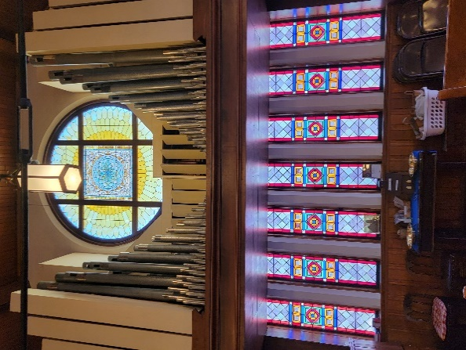
Forest Presbyterian Church was constructed in 1894 in the shingle style, with Gothic elements. It was designed by noted Albany architect Albert W. Fuller. The Church is described in the National Register of Historic Places, as retaining a “substantial degree of . . . historic architectural integrity.” Today, the Church’s treasured Rose Window, in the gable, is in urgent need of repair.
The Rose Window, a stained-glass panel, nine feet in diameter, of mostly yellow hues, was a gift to the Church from Mrs. Florence Merriam, grand-daughter of Caleb Lyon, whose family contributed so significantly to the development of the area that the village of Lyons Falls (originally High Falls) now bears their name. Ms. Merriam brought the window back from Brussels, along with a “sister window” for her Lyons Falls estate called the “Florissant.” In 1955, a new pipe organ was constructed in harmony with the Rose Window, and one rank of pipes from the Church’s original organ still offers the diapason (tones) of the violin.
Although, our main goal is to repair the rose window with the funds we raise. Addition money will go to support the renovation of the stained-glass windows underneath. This info came from the GoFundMe Support page at:
https://gofund.me/c7c658a9

